EVENT MANAGEMENT SYSTEM

Cover Page

Project Title
Event Management System

Submitted By
Name: Abdul Moeez
Registration No: L1F23BSSE0185
Section: SEF-5

Course
Object-Oriented Programming / Java Programming

Submitted To

Muhammad Abdul rehman hashmi

Submission Date

17-6-26

1. Introduction
The Event Management System is a Java-based desktop application developed to simplify the process of managing events and participants. The system provides an easy-to-use graphical user interface that allows users to add, view, search, update, and delete event records efficiently.
This project demonstrates the practical implementation of Java programming concepts, Object-Oriented Programming (OOP), exception handling, input validation, and graphical user interface development using Java Swing.

2. Objectives
The main objectives of this project are:
- To develop a user-friendly event management application.
- To manage event information efficiently.
- To provide event searching functionality.
- To reduce manual record management.
- To apply Object-Oriented Programming concepts.
- To improve programming and software development skills using Java.
- To demonstrate CRUD (Create, Read, Update, Delete) operations.

3. Problem Statement
Managing events manually can be difficult and time-consuming. Organizers often face problems in maintaining event records, searching for specific events, and updating information when required.
The Event Management System solves these problems by providing a computerized solution that allows users to manage event records easily through a graphical user interface. The system improves efficiency, accuracy, and accessibility of event information.

4. System Features
The system provides the following features:
- User Login System
- Add New Event
- View Events
- Search Event
- Update Event
- Delete Event
- Input Validation
- Exception Handling
- User-Friendly Dashboard

5. OOP Concepts Used
The following Object-Oriented Programming concepts have been implemented:

Classes and Objects
Used to create Event, User, Admin, and Manager objects.

Encapsulation
Data members are declared private and accessed through getter and setter methods.

Inheritance
Admin class inherits properties from the User class.

Polymorphism
Method overriding is implemented in the Admin class.

Constructors
Constructors are used to initialize object data.

Method Overloading / Overriding
Methods are overridden to demonstrate runtime polymorphism.

6. Testing

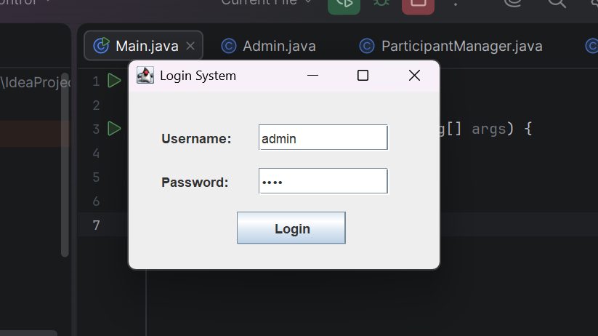

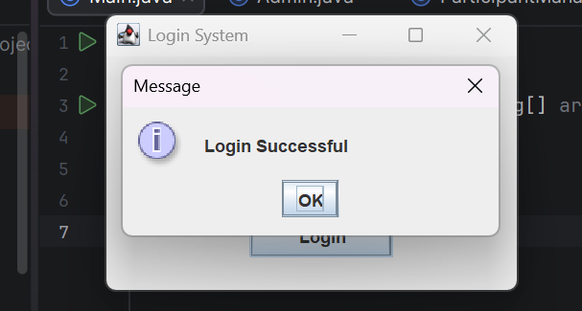

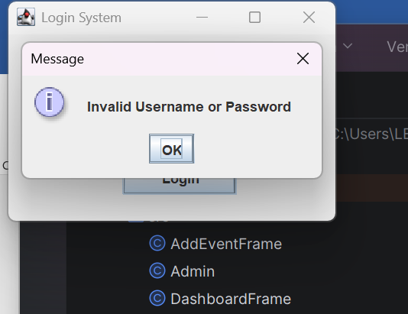

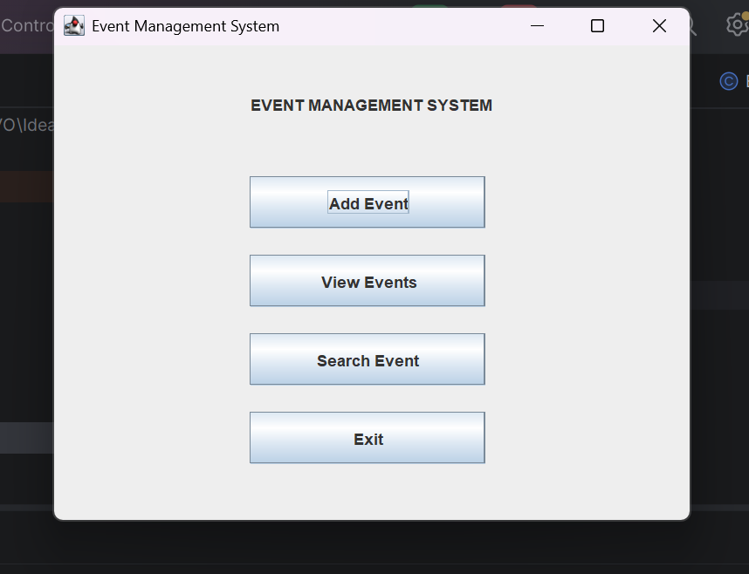

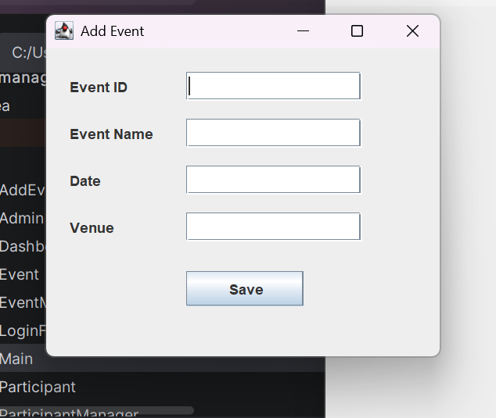

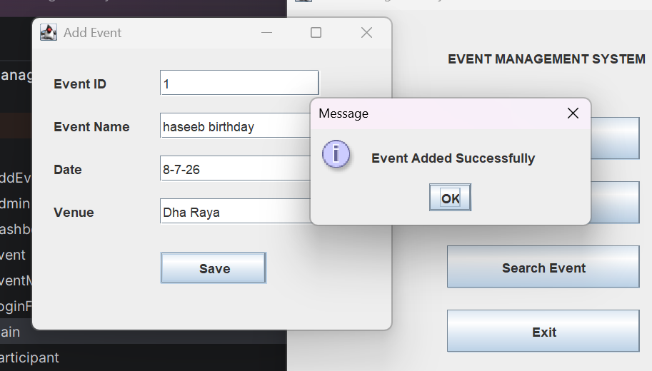

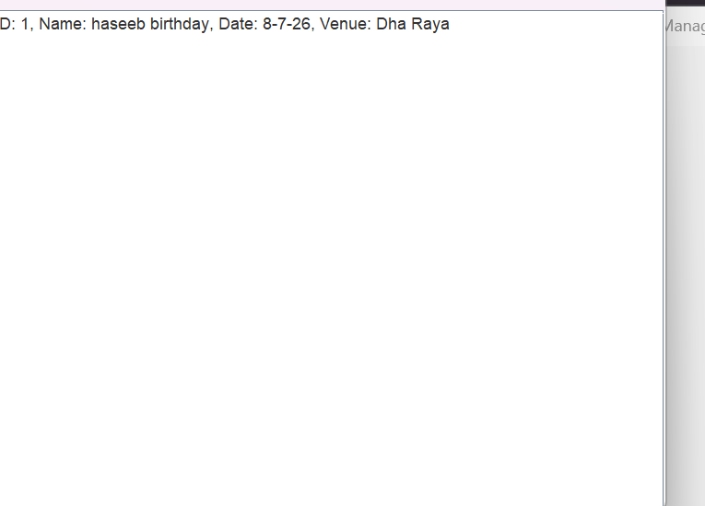

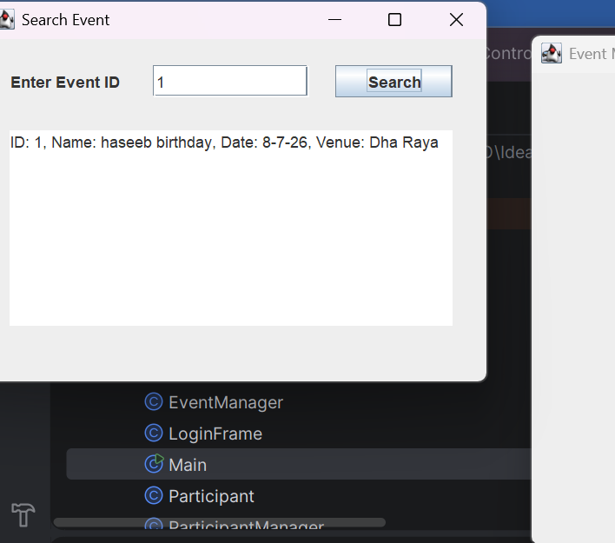

7. Testing
The application was tested using different scenarios.

Test Case 1
Input: Valid Username and Password
Expected Result: Login Successful
Actual Result: Login Successful

Test Case 2
Input: Invalid Username or Password
Expected Result: Error Message
Actual Result: Error Message Displayed

Test Case 3
Input: Add New Event
Expected Result: Event Added Successfully
Actual Result: Event Added Successfully

Test Case 4
Input: Search Existing Event
Expected Result: Event Details Displayed
Actual Result: Event Details Displayed

Test Case 5
Input: Search Non-Existing Event
Expected Result: Event Not Found
Actual Result: Event Not Found Message Displayed

7. Conclusion
The Event Management System successfully provides a simple and efficient solution for managing events. The project helped in understanding Java programming, GUI development, exception handling, and Object-Oriented Programming concepts. The application can be used to organize and manage event information effectively.

8. Future Enhancements
The following improvements can be added in future versions:
- Database Connectivity using MySQL
- Online Event Registration
- Email Notifications
- Attendance Management
- Report Generation
- Multi-User Access System
- Event Scheduling and Reminders
- Advanced Search Filters

Technologies Used
- Java
- Java Swing
- IntelliJ IDEA
- Object-Oriented Programming Concepts
- Java Collections Framework

